Push-Pull Audio Amplifier with BJTs along with Wireless Bluetooth & wired Audio Input

Engr. Furqan Shahid Team Leader
Dept. of Mechatronics and Control Engineering
University of Engineering and Technology
Lahore, Pakistan
engr.furqanshahid64@gmail.com
Noor ul Ain Amjad
Dept. of Mechatronics and Control Engineering
University of Engineering and Technology
Lahore, Pakistan
engr.noorulainamjad72@gmail.com

Abstract— This project presents the design and implementation of a Push-Pull Class B audio amplifier, enhanced with wireless audio input functionality via a Bluetooth audio receiver module. The amplifier is designed using a pair of complementary transistors configured in a push-pull arrangement to achieve efficient amplification with reduced distortion. The addition of a Bluetooth module enables users to wirelessly transmit audio signals from a smartphone or any Bluetooth-enabled device to the amplifier input, eliminating the need for physical wiring. The entire system was first simulated using Proteus, followed by PCB design, fabrication, and testing on real hardware.
Keywords— Push-pull amplifier, audio amplifier, Class B amplifier, transistor amplifier, Bluetooth audio, wireless input, PCB design, complementary transistors, audio electronics, hardware project, Proteus.
- Project Overview
This project focuses on building a Class B push-pull amplifier using complementary transistor pairs (NPN and PNP) to amplify audio signals with low power loss and reduced crossover distortion. The amplifier accepts both wired and wireless audio inputs, where the wireless option is enabled using a compact Bluetooth audio receiver module (not HC-05), designed specifically for audio streaming.
The real-world audio signal is received wirelessly via Bluetooth or through a 3.5mm AUX cable, passed through a biasing stage, and then amplified using the push-pull configuration.
The project was implemented first in Proteus, where the circuit was tested for waveform response, frequency handling, and distortion. Once verified, the schematic was converted into a PCB layout.
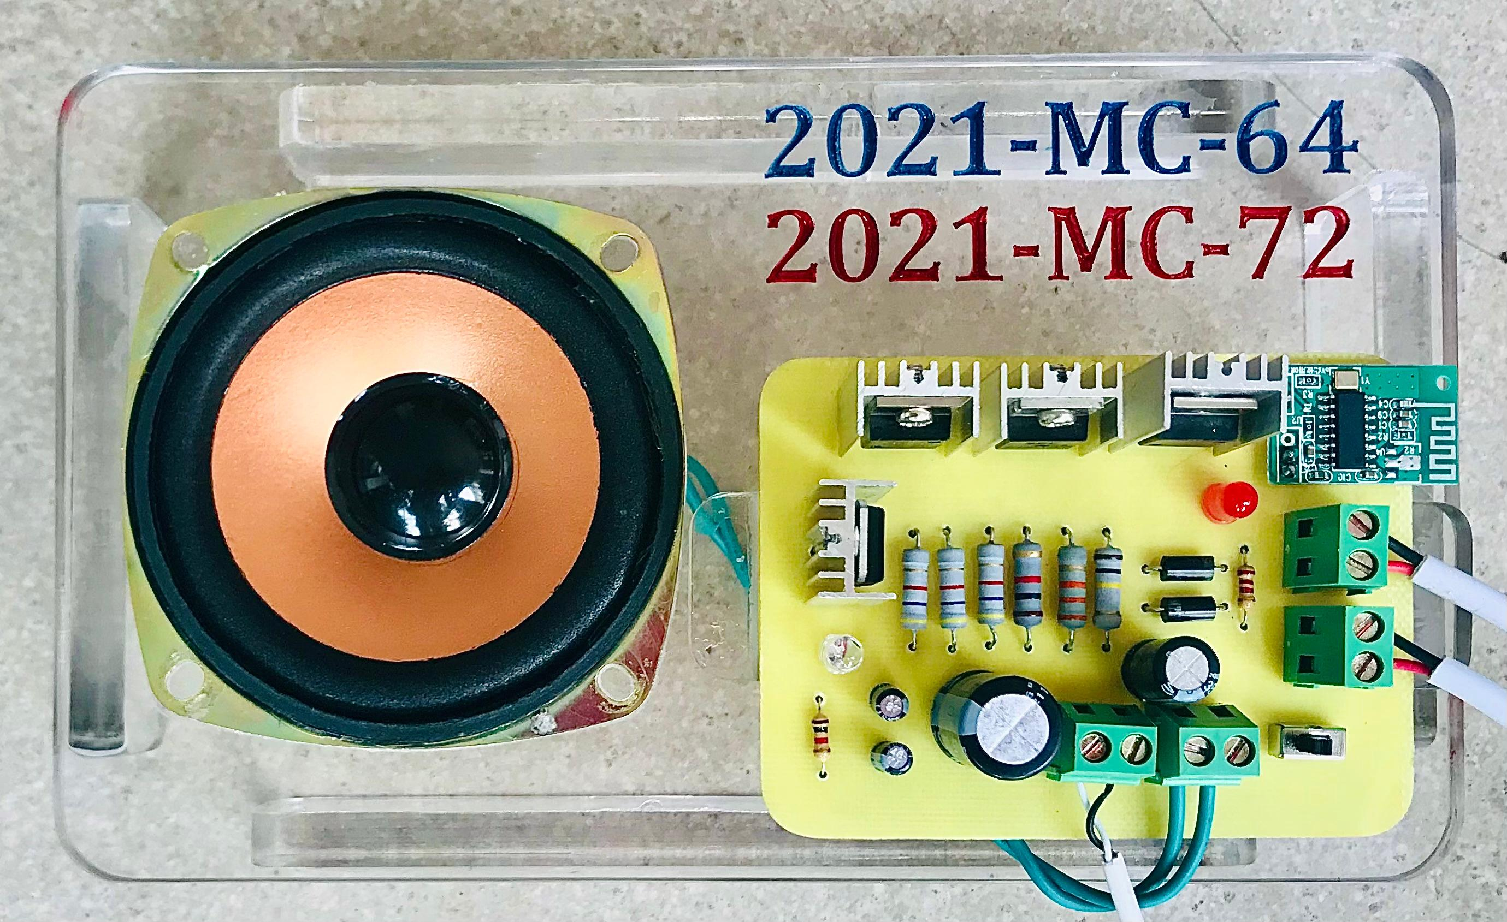
Fig. 1: Fully Assembled Push-Pull Amplifier with Bluetooth Module on PCB
- Process
The development process began with designing the push-pull amplifier circuit in Proteus using an NPN and PNP transistor pair (commonly BD139 and BD140 or similar). The circuit was biased with the help of resistors and diodes to minimize crossover distortion and ensure class B operation. Capacitive coupling was used at the input and output stages to block DC offsets.
Once the circuit performance was verified through simulation, especially for its ability to amplify a sine wave input without distortion, the schematic was transferred to the PCB layout section of Proteus. The layout was designed with short signal paths and sufficient spacing for heat dissipation. A separate section was provided for integrating the Bluetooth audio module, which was powered by the same supply but isolated from the audio output to avoid noise coupling.
The PCB was then fabricated, and all components including the transistors, capacitors, resistors, and the Bluetooth receiver were soldered onto the board. Upon power-up, the system successfully paired with a smartphone, and wireless music playback was tested through a connected speaker. The audio output was clear, amplified, and stable.
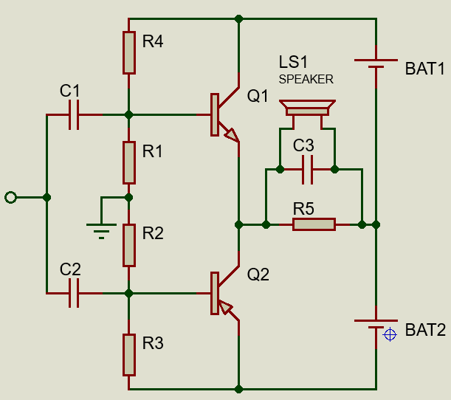
Fig. 2: Push-Pull Amplifier Circuit Simulation in Proteus
After successful simulation of the push-pull amplifier circuit in Proteus, the next step was to design the PCB layout. The components were carefully arranged to minimize signal noise, ensure proper heat dissipation, and maintain compactness. Special attention was given to audio input and output routing to avoid distortion or feedback issues. The final PCB layout was optimized for both performance and ease of assembly.
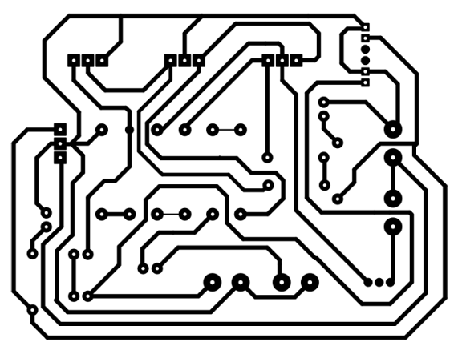
Fig. 3: PCB Design for Push-Pull Amplifier
- working principle
A push-pull amplifier uses two transistors operating in opposite phases to amplify the positive and negative halves of the input signal. In this configuration, one transistor (NPN) conducts during the positive half-cycle while the other (PNP) conducts during the negative half-cycle. This reduces power loss and distortion, resulting in improved audio fidelity.
The Bluetooth audio receiver module connects wirelessly with smartphones or other Bluetooth-enabled devices and feeds the audio signal into the amplifier’s input stage. The amplified output is then sent to a speaker or load. Capacitors are used for coupling, and biasing resistors ensure correct operation of both transistors.
- applications
This push-pull amplifier project can be applied in a wide range of audio-based systems, including DIY Bluetooth speakers, portable audio amplifiers, desktop audio solutions, and basic home stereo setups. Due to its wireless connectivity, it offers flexibility and convenience for users looking to stream music without physical connections. Its compact size and discrete component design make it ideal for students, electronics hobbyists, and entry-level engineers working on analog circuits, audio signal processing, or low-power consumer electronics projects. Additionally, it serves as a useful educational example for understanding Class B amplifier behavior and wireless module integration.
- component used
The Bluetooth module used is not HC-05, but a dedicated audio streaming receiver module, which is plug-and-play and doesn't require AT commands or manual pairing 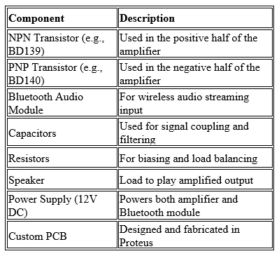
- conclusion
This project successfully demonstrates the design, simulation, and implementation of a Class B push-pull amplifier with integrated Bluetooth audio streaming capability. By using complementary NPN and PNP transistors, the amplifier delivers efficient and low-distortion audio amplification suitable for small speakers and personal audio systems. The wireless input feature, achieved using a compact Bluetooth audio module, enhances usability by allowing audio transmission from modern devices such as smartphones and laptops.
From schematic design and waveform simulation in Proteus, to PCB layout, hardware fabrication, and final real-time testing, this project provided a well-rounded learning experience in analog electronics, signal flow, and circuit debugging. The result is a reliable, cost-effective, and flexible amplifier that combines classic analog design with modern wireless input—making it a strong base for future improvements such as volume control, tone filtering, or digital signal input handling.
- references
[1] A. Sedra and K. Smith, Microelectronic Circuits, 7th ed., Oxford University Press, 2015.
[2] Electronics Tutorials, “Class B Amplifier,” [Online]. Available: https://www.electronics-tutorials.ws/amplifier/amp_6.html
[3] PCBWay, “PCB Design Tips for Audio Amplifiers,” [Online]. Available: https://www.pcbway.com/blog/technology/PCB_Design_Tips_for_Audio_Amplifiers.html
[4] Circuit Digest, “Bluetooth Audio Receiver Module Based Wireless Audio Amplifier,” [Online]. Available: https://circuitdigest.com/electronic-circuits/wireless-audio-amplifier-using-bluetooth
[5] STMicroelectronics, “BD139, BD140 Complementary Transistors Datasheet,” [Online]. Available: https://www.st.

